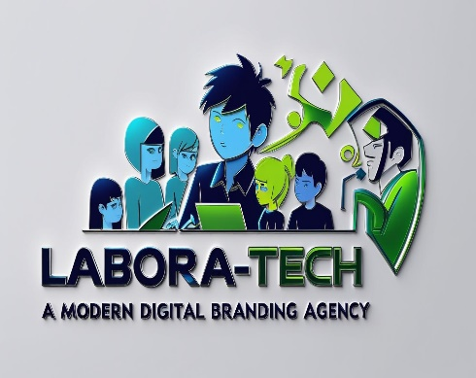

### Phase 1: Branding & Business Setup

**Brand Story: Labora-Tech – “Developing Youth as Future Tech Experts”**

At **Labora-Tech**, we believe the future doesn’t just happen—it’s created.

And the architects of that future? They’re sitting in classrooms today, full of untapped ideas, bold dreams, and limitless potential.

That’s why we exist: to equip youth with real-world tech skills and entrepreneurial vision so they don’t just adapt to the digital world—they lead it.

Our mission is simple, but powerful:  
**Teach. Empower. Transform.**  
We teach emerging technologies.  
We empower critical thinking and creativity.  
We transform young minds into future tech experts and entrepreneurs.

But we’re not just about coding classes or tech workshops. We’re about crafting **identities**—bold, dynamic, future-ready identities for the next generation. And we do it with the power of **AI-driven branding**.

At Labora-Tech, we use artificial intelligence not only as a teaching tool, but as a creative partner. Our AI systems analyze global tech trends, youth interests, design evolution, and digital engagement data to help our students build their **own personal brands, startup ideas, and tech solutions**. We teach them how to turn raw talent into meaningful impact—backed by data, sharpened by creativity, and supercharged by AI.

Whether they’re designing their first app, launching a digital product, or pitching a tech solution to real-world problems, our students aren’t just learning—they’re **building legacies**.

And with every logo they create, every prototype they pitch, and every venture they imagine, they’re guided by our AI-powered branding tools to ensure their ideas not only work—but **stand out**.

Because tomorrow’s challenges won’t be solved by followers.  
They’ll be solved by leaders who understand both **technology and storytelling**.  
By thinkers who can build, brand, and bring big ideas to life.

At Labora-Tech, we’re not just shaping tech talent.  
**We’re nurturing the minds that will define the digital future.**

**Phase 2: AI-Generated Design & Marketing Content**

1. **Social Media Content:** Generate AI-enhanced posts and graphics.

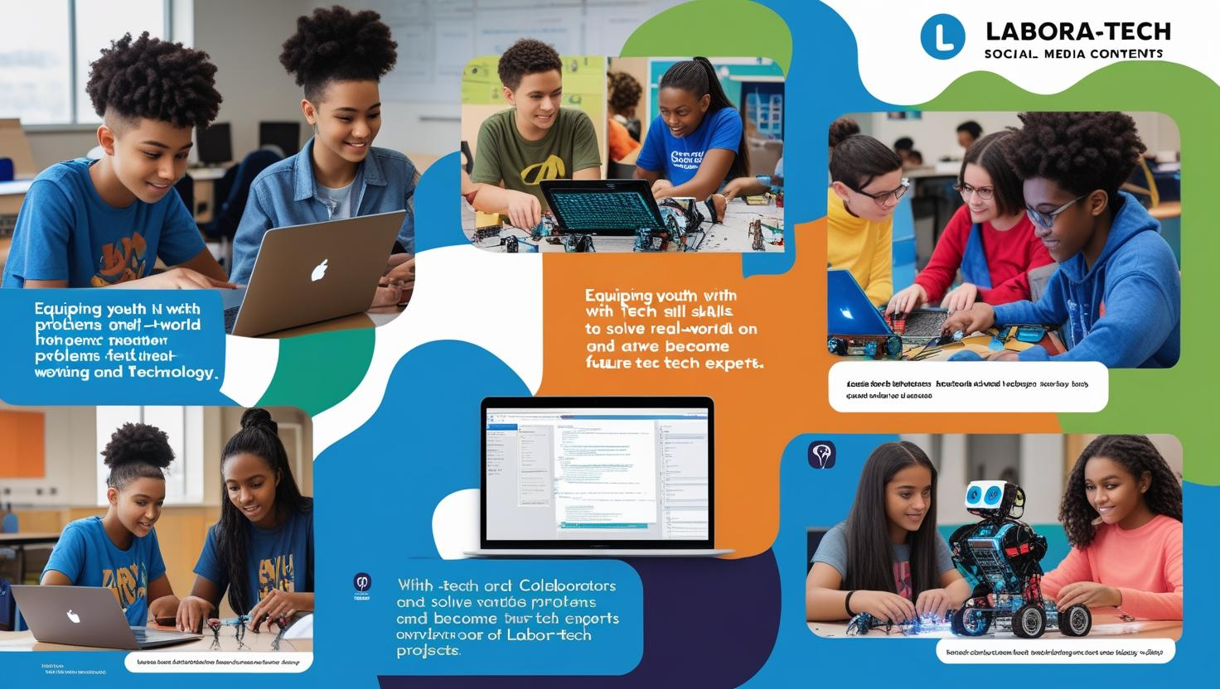

**Marketing Copy:**

# Why Businesses Should Embrace AI-Powered Branding to Stay Competitive

**In today’s fast-paced digital landscape, a strong brand is no longer a luxury—it’s a necessity. But with market trends shifting daily and consumer expectations evolving faster than ever, traditional branding methods are struggling to keep up. Enter** AI-powered branding**: the next-generation solution that’s helping businesses not just survive—but stand out.**

**At** Labora-Tech**, we’re on a mission to equip youth and startups with the tools they need to thrive in tech entrepreneurship. And branding is where it begins. Here's why more and more businesses are turning to AI to craft smarter, sharper, and more scalable brand identities.**

## **🔍 1.** Data-Driven Design Beats Guesswork

**Branding used to rely heavily on intuition and creative opinion. While creativity is still essential, AI enhances it with** data-backed insights**. AI tools can analyze millions of data points—like design trends, color psychology, industry benchmarks, and user engagement—to recommend logos, color schemes, taglines, and visual assets that actually work.**

Why it matters: **Data removes the guesswork. You get a brand that doesn’t just look good—it performs.**

## **⚡ 2.** Speed and Efficiency Without Compromise

**Building a brand manually can take weeks or even months. With AI-powered platforms, businesses can generate high-quality branding elements—like logo drafts, tone of voice guidelines, and even competitor analysis—in a matter of minutes.**

Why it matters: **Faster branding means faster go-to-market time. For startups and youth entrepreneurs, this speed is often the difference between seizing an opportunity—or missing it.**

## **🧠 3.** Personalization at Scale

**One of AI’s biggest strengths is its ability to** adapt branding to specific audiences**. From tailoring messaging based on user preferences to recommending visual styles that resonate with niche demographics, AI can help businesses craft hyper-personalized brand experiences.**

Why it matters: **In a crowded market, relevance is power. AI helps you speak directly to your ideal customers—at scale.**

## **💡 4.** Smarter Strategy, Not Just Better Design

**AI branding tools don’t stop at visuals. They offer** strategic insights **like keyword recommendations, competitor benchmarking, and customer sentiment analysis. That means businesses can build a brand that aligns with real market needs and user behavior.**

Why it matters: **Your brand isn’t just how you look—it’s how you think. AI helps you think smarter, earlier.**

## **🌱 5.** Leveling the Playing Field for Young Innovators

**At Labora-Tech, we work with youth who have brilliant tech ideas—but little access to traditional branding agencies. AI branding services help level the playing field, giving young creators access to tools once reserved for large companies.**

Why it matters: **Entrepreneurship should be about ideas, not gatekeeping. AI opens doors for the next generation.**

## **🚀 Final Thoughts: Branding for the Future, Not the Past**

**As AI continues to reshape every corner of business, branding is no exception. Companies that embrace AI-powered branding today are more agile, more relevant, and more competitive tomorrow. Whether you're a startup founder, a student launching a product, or a small business looking to scale, the future of branding is here—and it’s intelligent.**

**At** Labora-Tech**, we blend AI innovation with human creativity to help you craft a brand that not only reflects your vision but amplifies it.**

🔗 Ready to brand smarter? Let AI be your branding co-founder. **👉 [Start your AI-powered branding journey with Labora-Tech]**

### ****Phase 3: Client Outreach & Monetization****